**LAB TASK**

**IST WAY:**

1. The **mkdir** command is use to create a directory
2. I was in the home directory where I have created a directory called as **Grade.**

**mkdir Grade**

1. After that going into grade directory I have created three more directories using the same mkdir command as

**mkdir Grade/A**

**mkdir Grade/B**

**mkdir Grade/C**

1. Now going into A B and C directories I have created the asked directories

**mkdir Math’s**

**mkdir Physics**

**mkdir Maths**

**mkdir Physics**

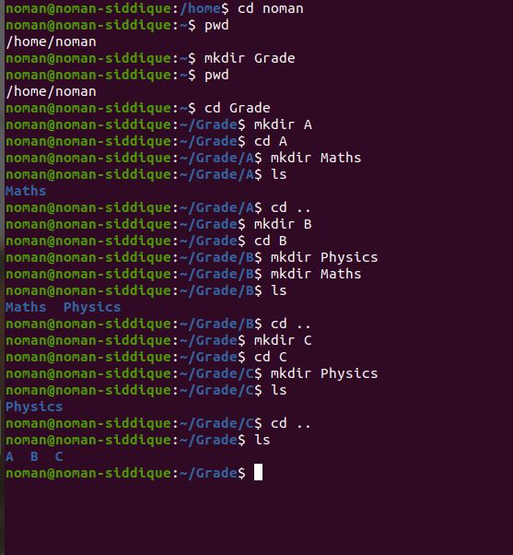

**2nd way:**

This is the short way of doing thing

1. First I have created a directory as **grade**

**mkdir grade**

1. Then have created three directories as

**mkdir grade/A**

**mkdir grade/B**

**mkdir grade/c**

1. Then have created direct directories as

**mkdir grade/A/Maths**

**mkdir grade/**B**/Maths**

**mkdir grade/B/Phsyics**

**mkdir grade/C/Maths**

